**Logger.java:-**

In the logger.java file I’ve implemented the Logger class.

The code is as follows:

**package week1;**

public class Logger {

private static Logger *curlog* = new Logger();//log object

private Logger() {

System.*out*.println("Logger Class Called");

}

static Logger getInstance() {

return *curlog*;

}

//logging method

public void log(String msg) {

System.*out*.println(msg);

}

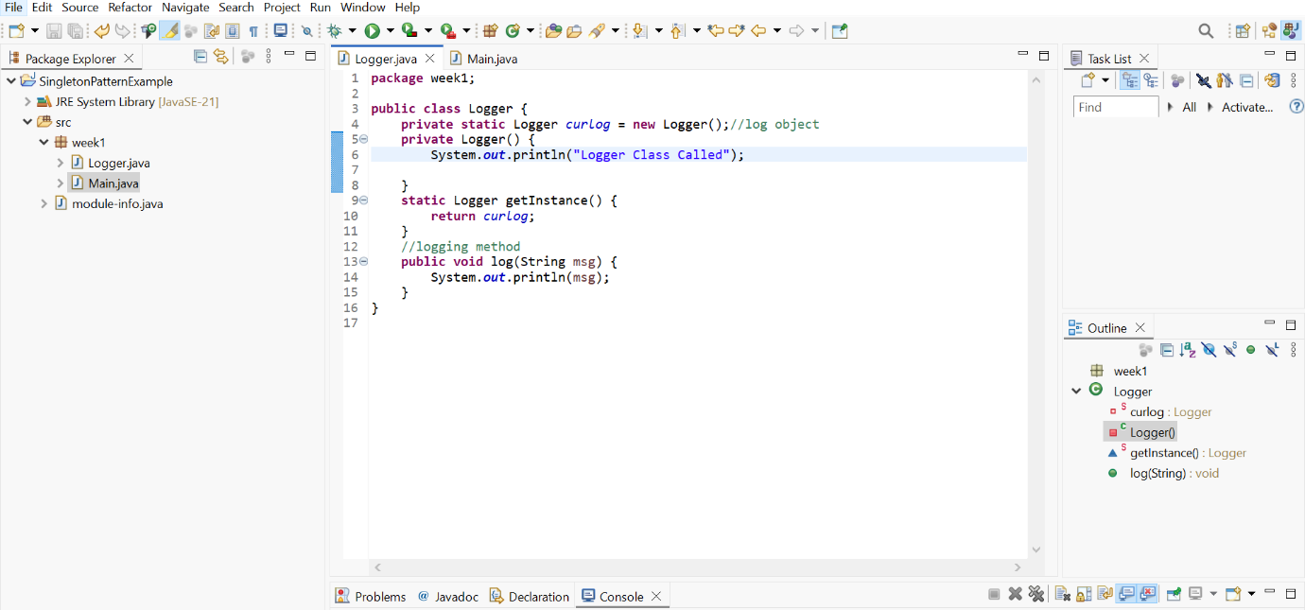}

**Main.java :-**

In the main.java I’ve implemented the main method and called the logger class and verified it.  
The code of the Main.java is as follows:

**package** week1;

**public** **class** Main {

**public** **static** **void** main(String[] args) {

Logger log1 = Logger.*getInstance*();

log1.log("log1");

Logger log2 = Logger.*getInstance*();

log2.log("log2");

**if**(log1==log2) {

System.***out***.println("log1 and log2 Objects are Same");

}**else** {

System.***out***.println("log1 and log2 Objects are not Same");

}

}

}

The output of this is as follows:

